
EBT Point-of-Sale Terminal

USER MANUAL
Complete Operating Guide for Merchants and Cashiers
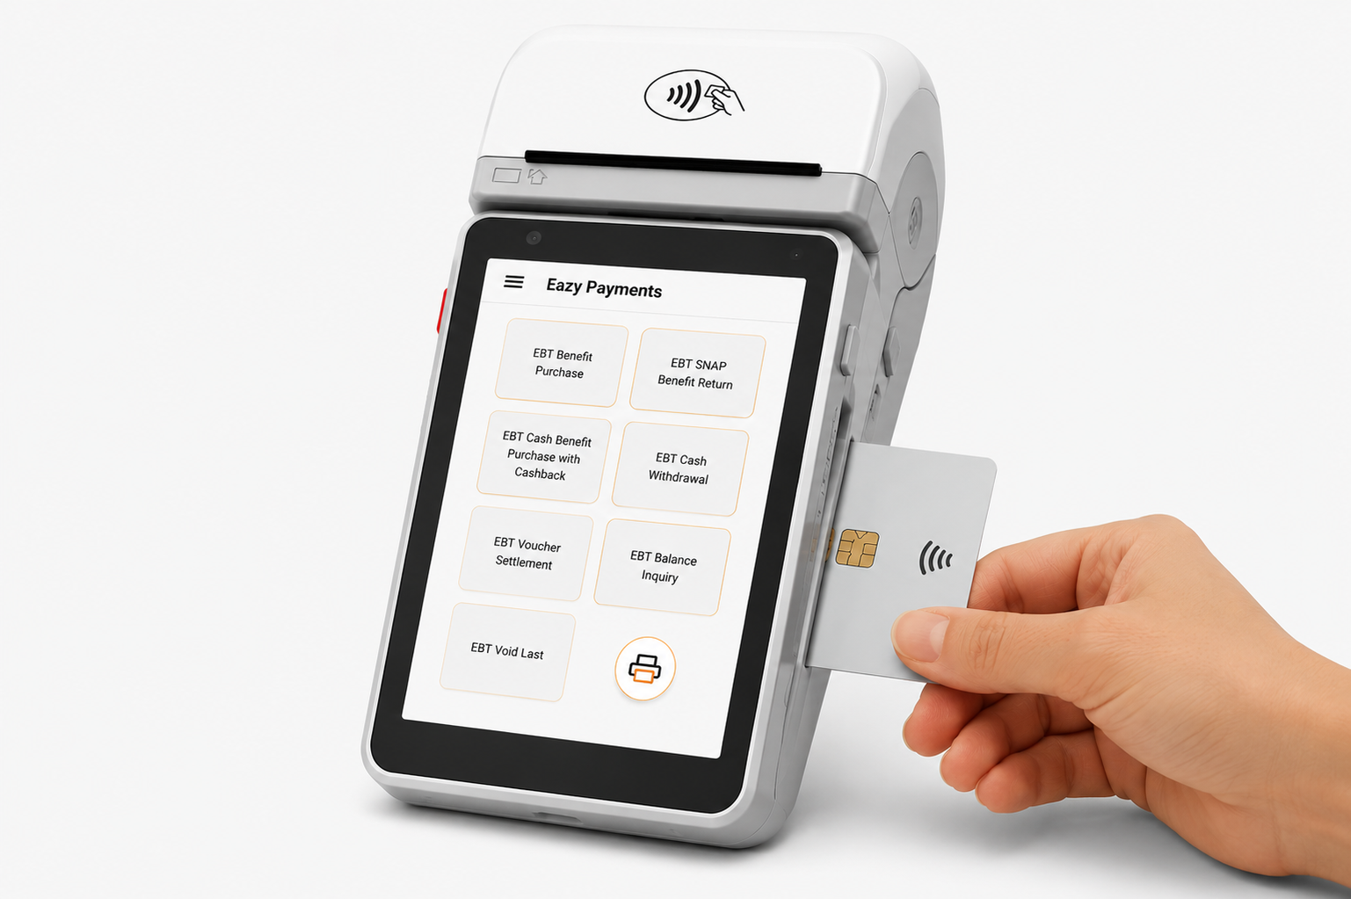

Document Version | 1.1
Issue Date | May 2026
Platform | EazyPay Tech Android POS Terminal
EBT Network | Conduent EBT (SNAP & Cash Benefits)
Audience | Merchants, Cashiers, Store Managers
Classification | Confidential — For Merchant Use Only

Revision History
Sr.No | Date | Version | Description | Author Name
1 | April 2026 | 1.0 | Initial Draft
2 | May 2026 | 1.1 | • Implemented Chip and Tap handling based on service codes 2 and 6. Swipe is restricted unless both Chip and Tap are disabled.  • Added the Manual Entry button to the transaction screen.  • Implemented fallback to Swipe after three failed card insert attempts.  • Updated receipt data and alignment as per requirements.

Contents
Introduction. 7
Overview of the EBT Program 8
The EBT SNAP and CASH Benefit Transfer Program 8
1 Getting Started & Login Process 9
1.1 Powering on the Terminal 9
1.2 Activation Login 9
1.3 Network Sign-On (0800 Message) 12
1.4 Main Menu 12
1.5 First-Time Activation 13
1.6 New Build Activation 14
2. EBT SNAP Benefit Purchase 16
2.1 Overview 16
2.2 Step-by-Step Screen Prompts 17
2.3 Receipt Formats 22
3. EBT Cash Benefit Purchase 23
3.1 Overview 23
3.2 Step-by-Step Screen Prompts 23
3.3 Receipt Formats 28
4. EBT Cash Purchase with Cash Back 29
4.1 Overview 29
4.2 Step-by-Step Screen Prompts 29
4.3 Receipt Format 35
5. EBT SNAP Benefit Return 36
5.1 Overview 36
5.2 Step-by-Step Screen Prompts 36
5.3 Receipt Formats 41
6. EBT Cash Withdrawal 42
6.1 Overview 42
6.2 Step-by-Step Screen Prompts 42
6.3 Receipt Formats 47
7. EBT Balance Inquiry 48
7.1 Overview 48
7.2 Step-by-Step Screen Prompts 48
7.3 Receipt Formats 53
8. EBT Void Last Transaction 54
8.1 Overview 54
8.2 Step-by-Step Screen Prompts 54
8.3 Receipt Formats 57
9. EBT Voucher Settlement 58
9.1 Overview 58
9.2 Screen Prompts 58
9.3 Receipt Format 64
10. Manual Card Entry 65
10.1 When to Use Manual Entry 65
10.2 Receipt Format 69
11. ISO 8583 Request / Response Overview 70
11.1 Message Types (MTI) 70
11.2 Key Data Fields 70
11.3 Transaction Message Flow 72
11.4 Sample Messages 73
12. Processor ID (PID),Terminal ID (TID) & Merchant ID (MID) Setup 75
12.1 Viewing PID ,TID and MID. 75
12.2 Changing the Terminal ID (TID) 76
12.3 Changing the Merchant ID (MID) 79
13. Merchant Configuration & Parameters 82
13.1 Configuration Parameters 82
13.2 Changing Parameters 83
13.3 Network / Host Settings 85
14. Error Codes & Troubleshooting 86
14.1 Response Codes (DE39) 86
14.2 Hardware Error Messages 86
14.3 Quick Fixes 87
15. POS Logs Collection and Upload Process TMS Portal 88
16. MoreFun M90 Setup Guide 94
16.1 Insert Paper Roll 94
16.2 MoreFun M90 Features 95
16.3 Maintenance and Troubleshooting – 95
17. Glossary 98

Introduction
Welcome to the EazyPayTech EBT(Electronic Benefits Transfer) Point-Of-Sale Terminal User Manual
This manual provides comprehensive instructions for operating the EazyPayTech Android-based POS terminal for EBT transaction processing. The EBT Program has partnered with EazyPayTech to deliver a secure, reliable, and efficient electronic payment solution that enables authorized participants to access their SNAP and Cash benefits through the Conduent EBT network.
The EazyPayTech POS system is designed to simplify EBT payment processing for merchants while ensuring fast transaction authorization, improved security, and reduced risk of fraud. The system supports multiple transaction types, including SNAP purchases, Cash benefit purchases, Cash withdrawals, Balance inquiries, Returns, Voids, and Voucher settlements.
This user manual includes:
- Terminal activation and login procedures
- Step-by-step transaction processing instructions
- Card entry methods (Tap, Insert, Swipe, and Manual Entry)
- Receipt examples and transaction flows
- ISO 8583 request/response reference information
- Merchant configuration settings
- Error codes and troubleshooting procedures
- POS log collection and upload process
All merchants, cashiers, store managers, and support personnel using the EazyPayTech POS terminal should carefully follow the procedures and guidelines provided in this manual to ensure secure and successful transaction processing.
Please keep this manual available near the POS terminal for quick reference during daily operations.

Overview of the EBT Program
The Electronic Benefits Transfer (EBT) Program is a secure electronic payment system that allows eligible participants to access government-issued SNAP (Supplemental Nutrition Assistance Program) and Cash benefits using an EBT card. The card functions similarly to a standard debit card and can be used at authorized retail locations equipped with certified EBT Point-of-Sale (POS) terminals.
The EBT Program is designed to provide fast, secure, and convenient benefit distribution while reducing the risks associated with paper vouchers and manual processing. Transactions are processed electronically through the Conduent EBT network, ensuring real-time authorization and balance verification.
All EBT transactions processed through the EazyPayTech POS terminal must comply with program regulations and retailer operating procedures. Proper use of the terminal ensures secure, accurate, and reliable benefit transactions for both merchants and cardholders.

The EBT SNAP and CASH Benefit Transfer Program
EBT Program Purpose
The purpose of the EBT (Electronic Benefits Transfer) Program is to provide a secure, efficient, and reliable system for distributing SNAP and Cash benefits to eligible participants. The program uses electronic payment technology to deliver benefits quickly and safely through authorized EBT POS terminals.
How Conduent Supports the Retailer
Conduent, as the EBT service provider, offers training and operational assistance to retailers using Conduent-supported EBT POS equipment. Retailers authorized to process EBT transactions must comply with EBT program requirements and retailer operating procedures.
Conduent provides retailer support services to assist merchants with EBT transaction processing, terminal operations, and troubleshooting activities.

1 Getting Started & Login Process

The EazyPayTech EBT Terminal must be signed on to the Conduent EBT network before processing any transactions.

1.1 Powering on the Terminal
- Press and hold the Power button (top-Left) for 2 seconds until the screen lights up.
- The EazyPayTech splash screen appears, followed by the Android launcher.
- Tap the EazyPayTech POS application icon.
- Allow up to 30 seconds for the application to fully load.

1.2 Activation Login
- The terminal requires Processor ID, TID & MID for device activation.
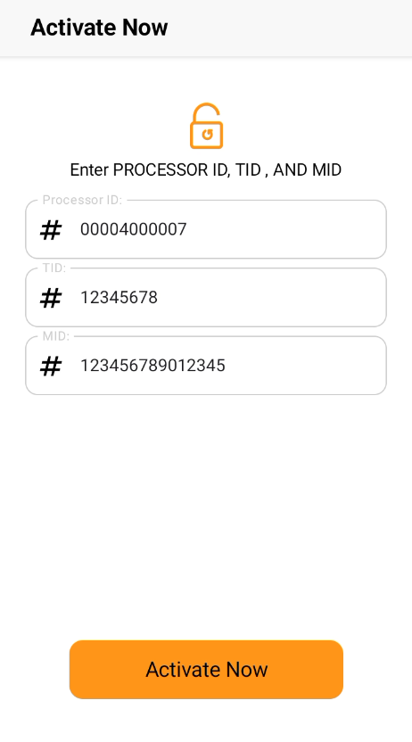

- Click on Activate Now.
- On Successful Device Activation Add User screen will be prompted.

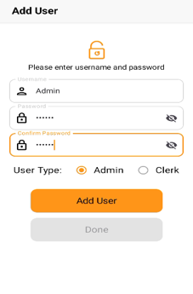

- Add User. Select the User type Admin or Clerk.

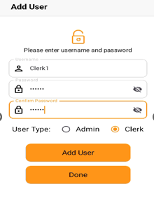
- After clicking on Add User you will get the User Added message which is as follows.
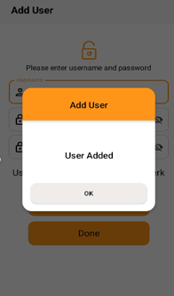
- After successfully adding the user app will navigate to Login page.
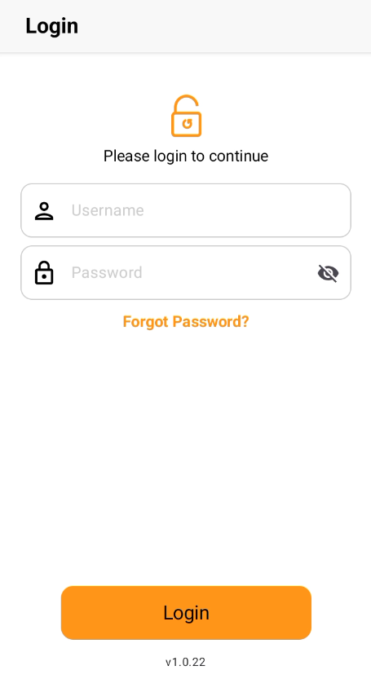

- Enter the username and password created in Step 4, then press ENTER.
- The main menu appears on success.

1.3 Network Sign-On (0800 Message)
The terminal automatically sends a Network Sign-On (ISO 8583 MTI 0800) when the application starts.



NOTE: If the terminal shows SIGN-ON FAILED, check Wi-Fi or cellular data and retry. If failure persists then so contact support.

1.4 Main Menu

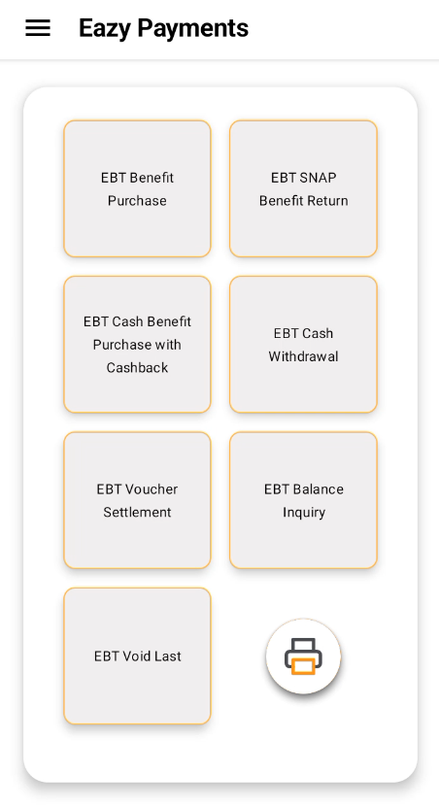

1.5 First-Time Activation
When the terminal is brand new or factory-reset, you must complete the activation flow before transactions are available.
- Enter Processor ID, Merchant ID, and Terminal ID (provided in your EazyPayTech onboarding pack).
- The system prompts you to create the first Admin user. At least one Admin user is required.
- Additional users with unique usernames and passwords can be created from the Admin panel.
- After successful authentication, activation completes. The screen shows 'Activation Successful'.
- Navigate to the Drawer and select Logout.
- Perform a fresh login to begin using the terminal.
Merchant Details

Processor ID | 00004000007
Merchant ID | 123456789012345
Terminal ID | 12345678
Merchant Name | 1388A TAYLOR AVE, PARKVILLE, MD
MCC | 5499
FNS Number | EB0070008596
State Code | 39

1.6 New Build Activation
- Uninstall the existing application from the device.
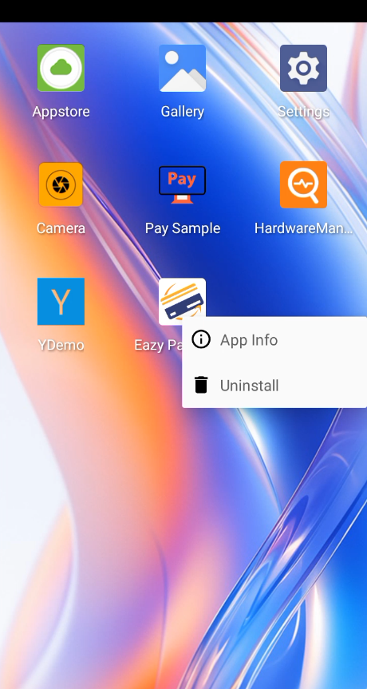
- Go to the App Store, open the application, navigate to the Home section, and select the option to upgrade the application.
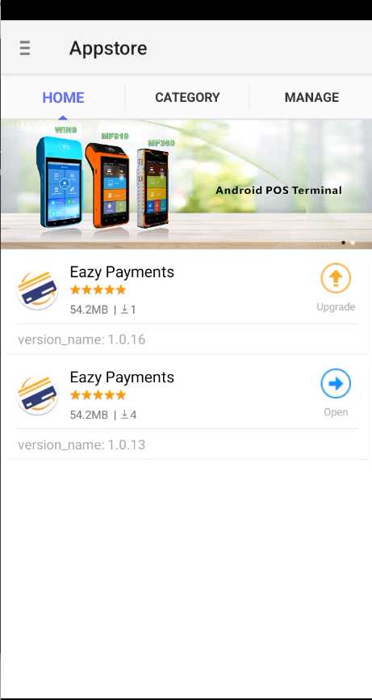

- Install the updated build (APK) and click the open
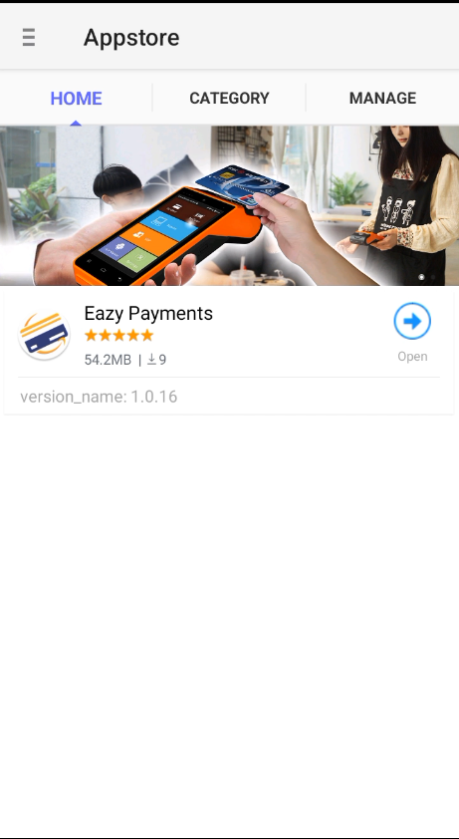
- During installation, the All-Files Access permission screen will appear.
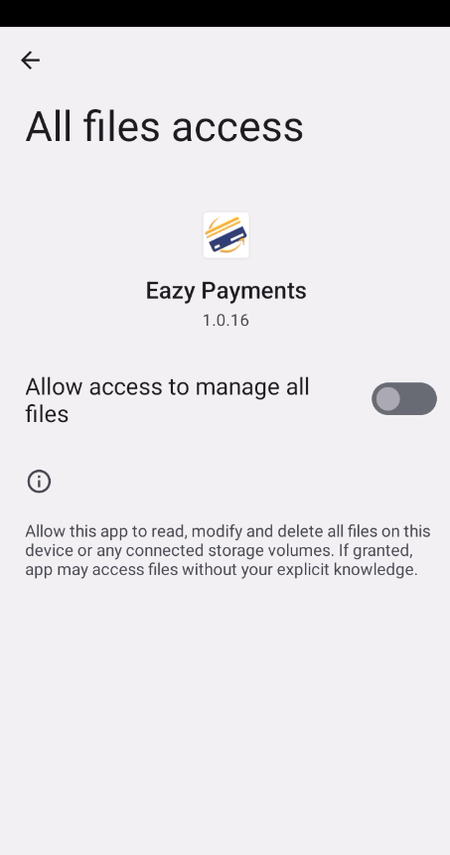

- Select Allow to grant file access permission and click the back arrow
- Complete the installation process.
- Launch the application and verify that it is working correctly.

2. EBT SNAP Benefit Purchase

2.1 Overview
Transaction Type | EBT SNAP Benefit Purchase
Processing Code | 009800
Entry Modes | Insert (Chip) / Tap (Contactless) / Swipe / Manual
PIN Required | Yes
Receipt Printed | Merchant Copy + Customer Copy
Eligible Items | SNAP-approved food items only

NOTE: SNAP benefits cannot be used for hot prepared foods, alcohol, tobacco, or non-food items as defined by USDA guidelines.

2.2 Step-by-Step Screen Prompts
Cashier selects - EBT SNAP Benefit Purchase' from the Main Menu.

- On selecting EBT Purchase SNAP benefits the app will navigate to screen having EBT SNAP benefit Purchase & EBT Cash benefit Purchase option.
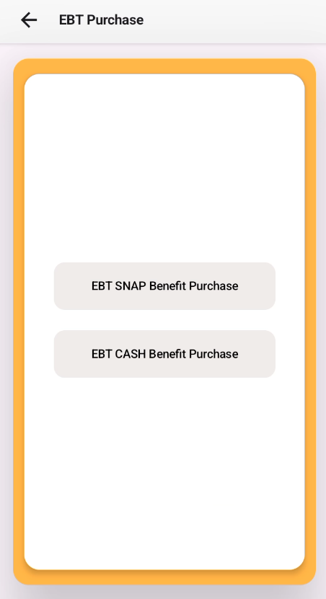
- Cashier types the sale amount (e.g. 100.00 for $1.00) and presses CONFIRM
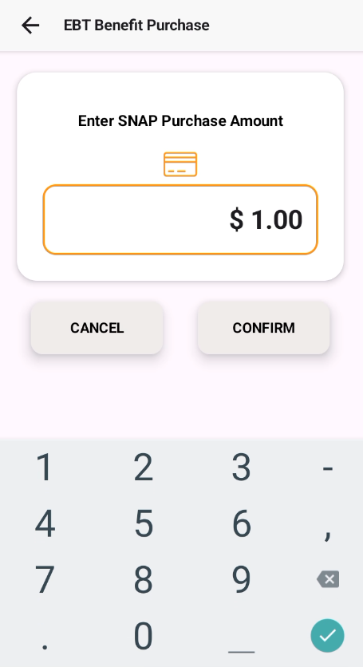
- Terminal confirms the amount and prompts for card:
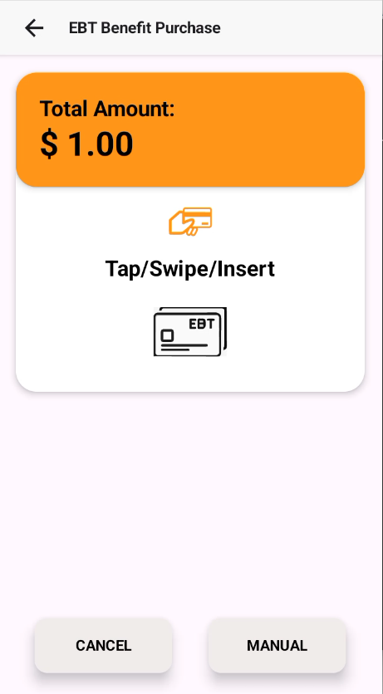
- If you want to choose from multiple options such as Tap, Swipe, Insert, or Manual Entry, the transaction will be processed accordingly.
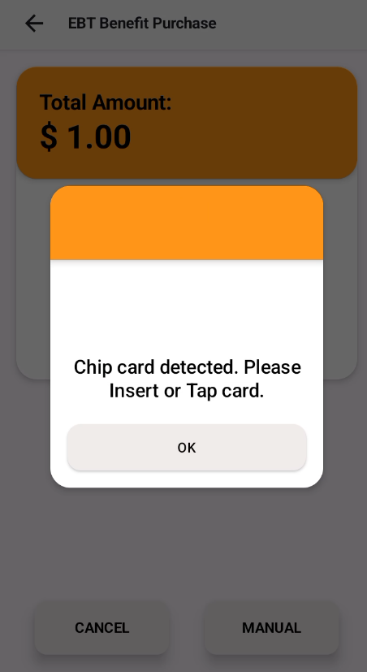
- If the service code starts with 2 or 6, it generally indicates that the card supports EMV chip functionality. The terminal should not process the swipe transaction immediately. Instead, it should prompt the customer with “Please Insert/Tap Card” and attempt chip processing first. If the chip transaction fails after the allowed retry attempts, then the terminal should proceed with swipe mode as a fallback transaction.
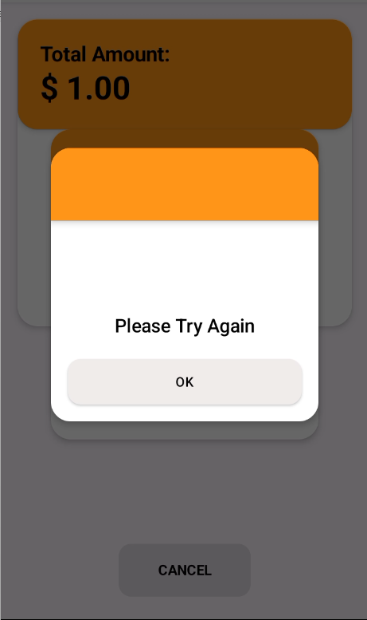
- In case card read successful through Tap, Chip, Swipe, Manual read then transaction continues to PIN prompt
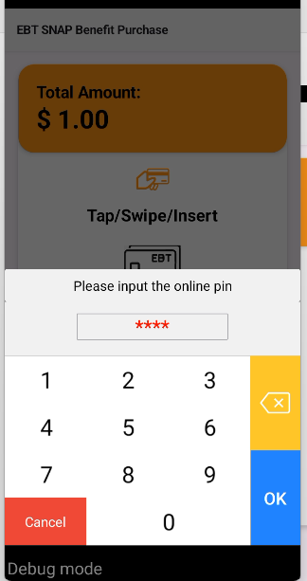

- The cardholder enters the PIN and presses ENTER. The terminal displays ‘Processing,’ and then shows the result—either approval or decline.

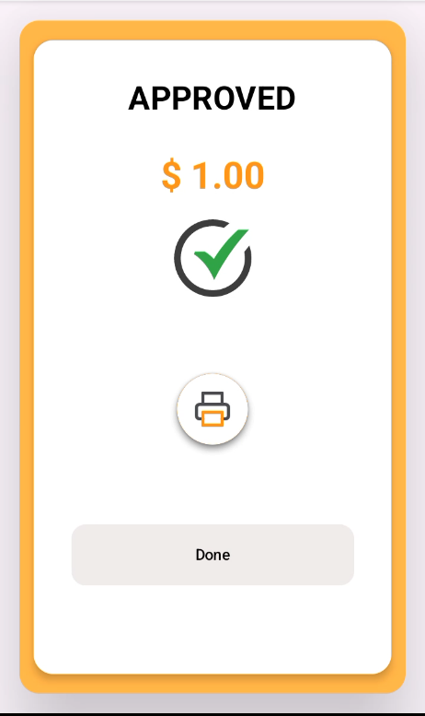
- If the transaction fails DECLINED screen will be displayed.
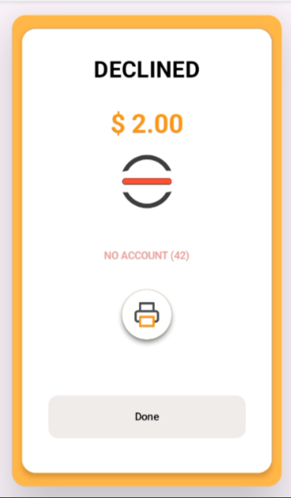

- Terminal prints Merchant Copy then Customer Copy. Transaction complete.

2.3 Receipt Formats

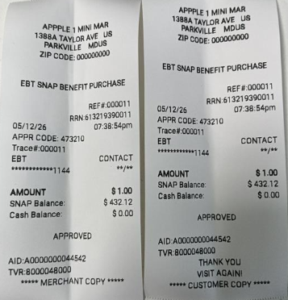

3. EBT Cash Benefit Purchase

3.1 Overview
Transaction Type | EBT Cash Benefit Purchase
Processing Code | 009600
Entry Modes | Insert / Tap / Swipe / Manual
PIN Required | Yes
Receipt Printed | Merchant Copy + Customer Copy
Eligible Items | Any eligible purchase — cash benefit has no item restrictions

3.2 Step-by-Step Screen Prompts
Cashier selects - EBT CASH Benefit Purchase' from the Main Menu.


- On selecting EBT Purchase SNAP benefits the app will navigate to screen having EBT SNAP benefit Purchase & EBT Cash benefit Purchase option.

- Cashier types the sale amount (e.g. 100.00 for $1.00) and presses CONFIRM
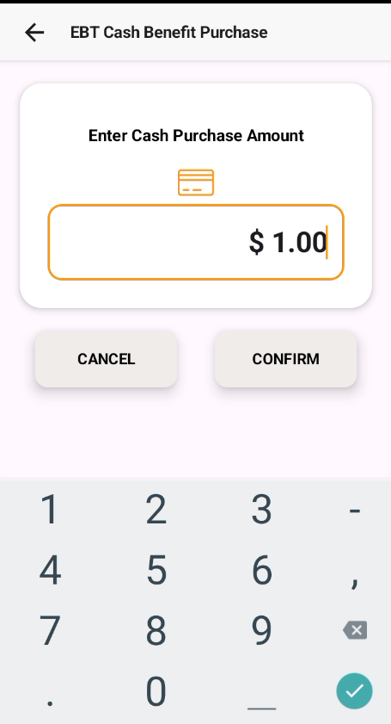

- Terminal confirms the amount and prompts for card.

- If you want to choose from multiple options such as Tap, Swipe, Insert, or Manual Entry, the transaction will be processed accordingly.

- If the service code starts with 2 or 6, it generally indicates that the card supports EMV chip functionality. The terminal should not process the swipe transaction immediately. Instead, it should prompt the customer with “Please Insert/Tap Card” and attempt chip processing first. If the chip transaction fails after the allowed retry attempts, then the terminal should proceed with swipe mode as a fallback transaction.
- If the Manual button is clicked, the application also switches to the Manual Entry scenario.
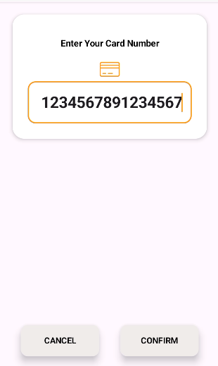
- In case card read successful through Tap,Chip,Swipe,Manual read then transaction continues to PIN prompt:

- The cardholder enters the PIN and presses ENTER. The terminal displays ‘Processing,’ and then shows the result—either approval or decline.


- If the transaction fails DECLINED screen will be displayed.


- Terminal prints Merchant Copy then Customer Copy. Transaction complete

3.3 Receipt Formats
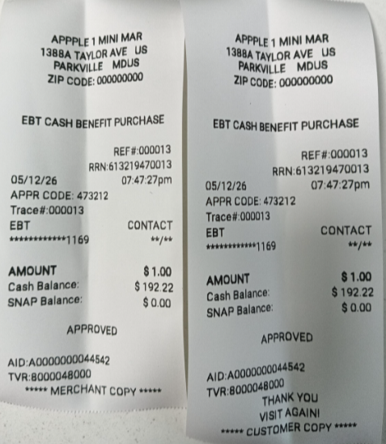

4. EBT Cash Purchase with Cash Back

4.1 Overview
Transaction Type | EBT Cash Benefit Purchase with Cash Back
Processing Code | 099600
Entry Modes | Insert / Tap / Swipe / Manual
PIN Required | Yes
Receipt Printed | Merchant Copy + Customer Copy
Note | Total debited = purchase amount + cash back amount

4.2 Step-by-Step Screen Prompts
- Selects EBT CASH Benefit Purchase with cashback' from the Main Menu.

- On selecting EBT Cash Benefit Purchase with Cashback the app will prompt to Enter Cash Purchase Amount.
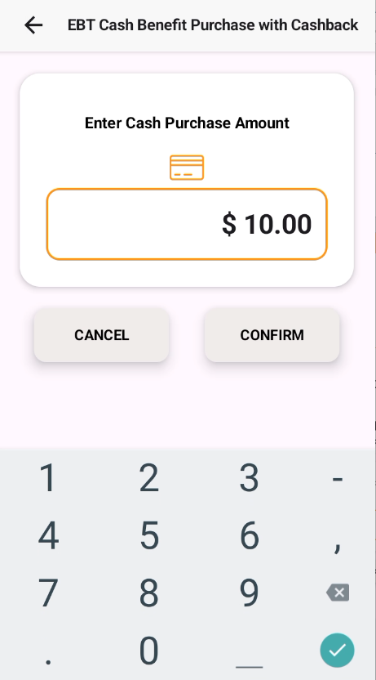

- Cashier types the sale amount (e.g. 100.00 for $10.00) and presses CONFIRM
- The application will navigate to Enter Cashback Amount screen.
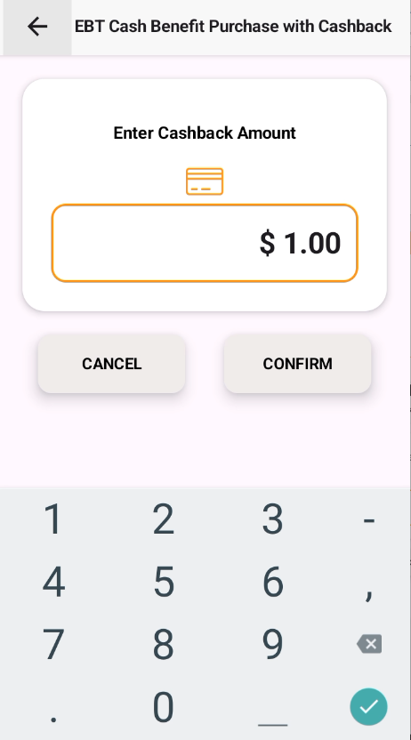
- Terminal confirms the amount and prompts for card.
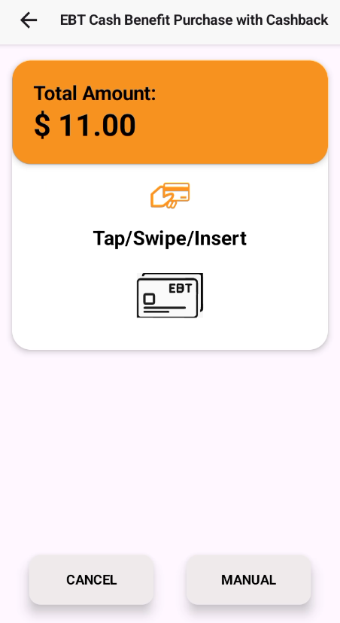
- If you want to choose from multiple options such as Tap, Swipe, Insert, or Manual Entry, the transaction will be processed accordingly.

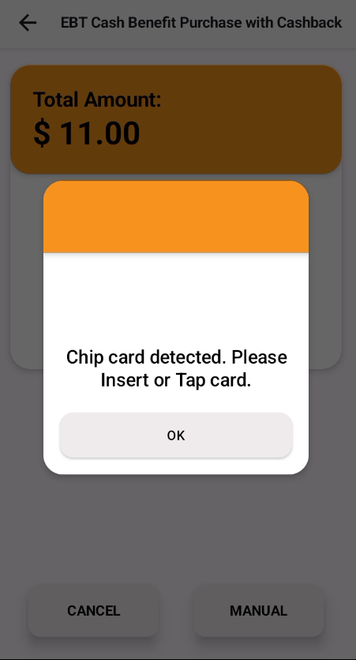
- If the service code starts with 2 or 6, it generally indicates that the card supports EMV chip functionality. The terminal should not process the swipe transaction immediately. Instead, it should prompt the customer with “Please Insert/Tap Card” and attempt chip processing first. If the chip transaction fails after the allowed retry attempts, then the terminal should proceed with swipe mode as a fallback transaction.

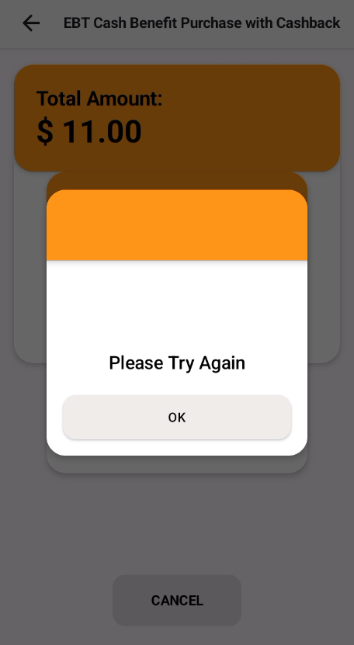

- If the Manual button is clicked, the application also switches to the Manual Entry scenario.


- In case card read successful through Tap,Chip,Swipe,Manual read then transaction continues to PIN prompt.

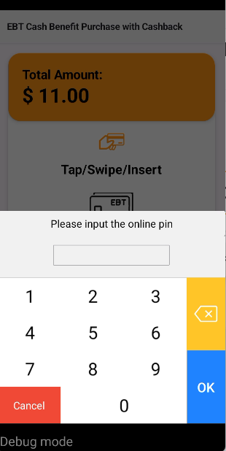
- The cardholder enters the PIN and presses ENTER. The terminal displays ‘Processing,’ and then shows the result—either approval or decline.
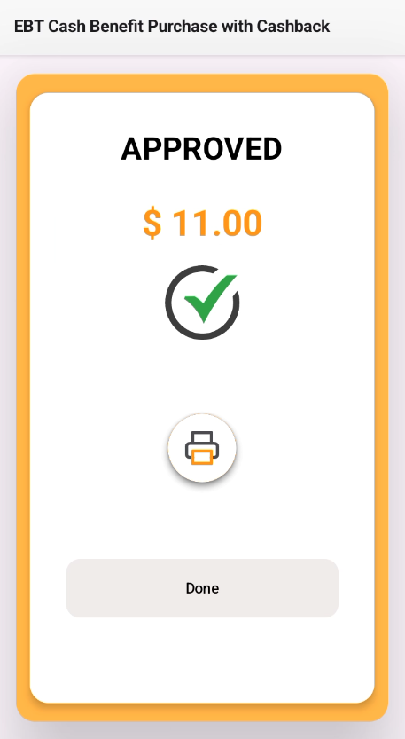

- If the transaction fails DECLINED screen will be displayed.

- Terminal prints Merchant Copy then Customer Copy. Transaction complete

4.3 Receipt Format

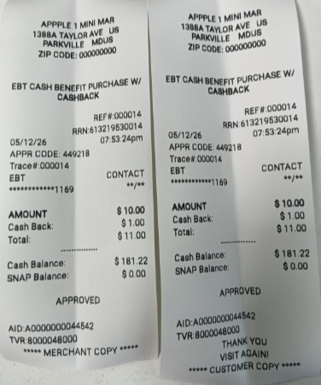

5. EBT SNAP Benefit Return

5.1 Overview
Transaction Type | EBT SNAP Benefit Return
Processing Code | 200098
Entry Modes | Insert / Tap / Swipe / Manual
PIN Required | Yes
Receipt Printed | Merchant Copy + Customer Copy
Note | Funds credited back to SNAP account. Only SNAP-eligible items can be returned to benefit account.

5.2 Step-by-Step Screen Prompts
- Cashier Select the EBT SNAP Benefit Return menu option from dashboard.

- On selecting EBT SNAP Benefit Return the app will prompt to Enter SNAP Return Amount

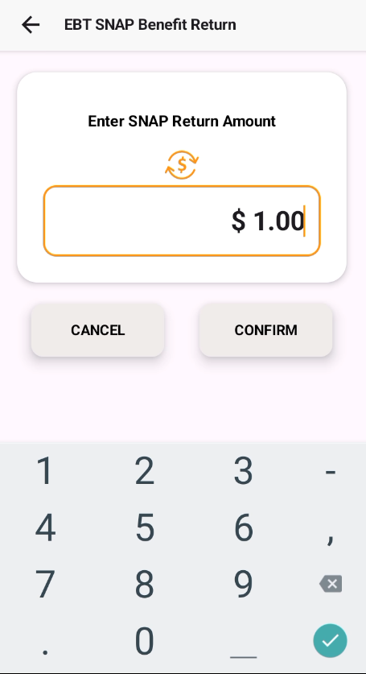
- Confirm amount.
- The application will navigate to Card presentation screen with Tap/Insert/Swipe /Manual option.
- Present the card with either of the options

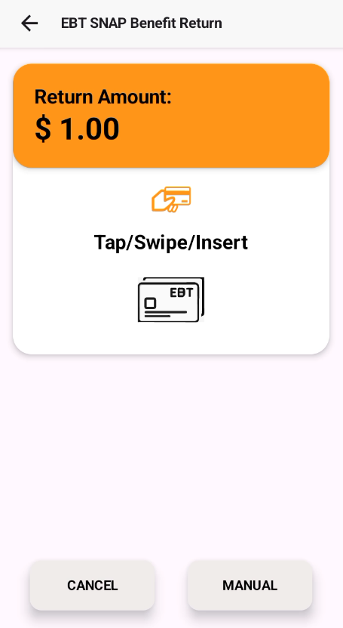
- If you want to choose from multiple options such as Tap, Swipe, Insert, or Manual Entry, the transaction will be processed accordingly
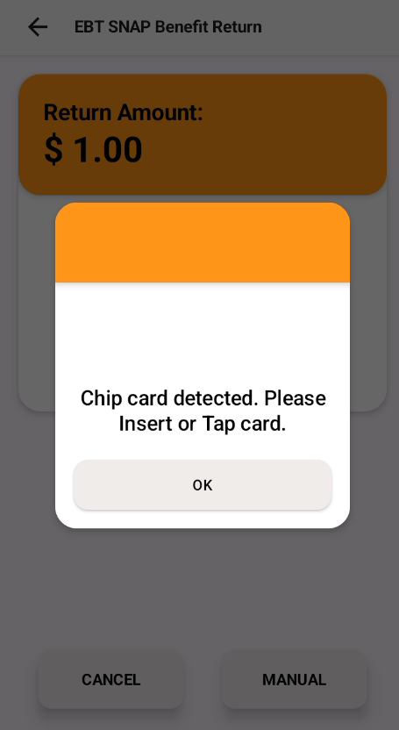
- If the service code starts with 2 or 6, it generally indicates that the card supports EMV chip functionality. The terminal should not process the swipe transaction immediately. Instead, it should prompt the customer with “Please Insert/Tap Card” and attempt chip processing first. If the chip transaction fails after the allowed retry attempts, then the terminal should proceed with swipe mode as a fallback transaction.
- In case card read successful through Tap,Chip,Swipe,Manual read then transaction continues to PIN prompt.
- Enter PIN. Click OK.
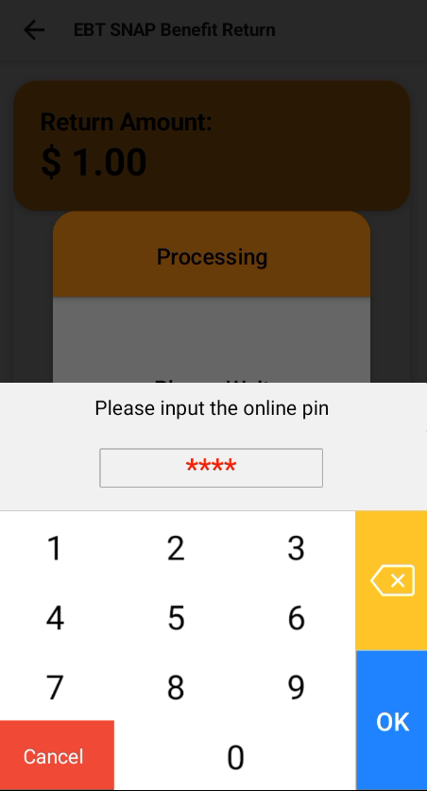

- Wait for the transaction to complete.
- On transaction success, APPROVED screen will be displayed


- If the transaction fails DECLINED screen will be displayed.



- Click on “Done” to return to Dashboard.
- Terminal prints Merchant Copy then Customer Copy. Transaction complete

5.3 Receipt Formats
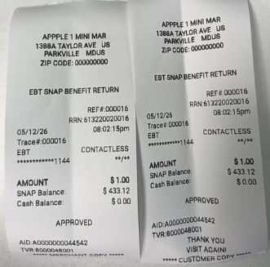

6. EBT Cash Withdrawal

6.1 Overview
Transaction Type | EBT Cash Withdrawal
Processing Code | 019600
Entry Modes | Insert / Tap / Swipe / Manual
PIN Required | Yes
Daily Limit | Subject to daily limit set by the benefit agency
Surcharge | May apply — configured in Merchant Settings

Step-by-Step Screen Prompts

Select the EBT Cash Withdrawal menu option from dashboard.

- On selecting EBT Cash Withdrawal the app will prompt to Enter Withdrawal Amount
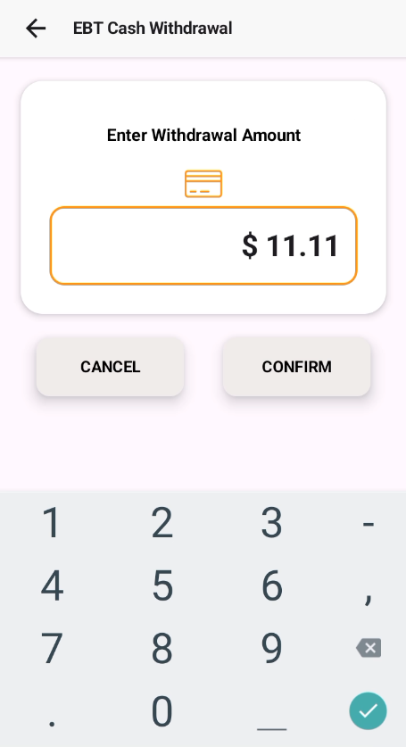

- Confirm amount.
- The application will navigate to Card presentation screen with Tap/Insert/Swipe option.
- Present the card with either of the options

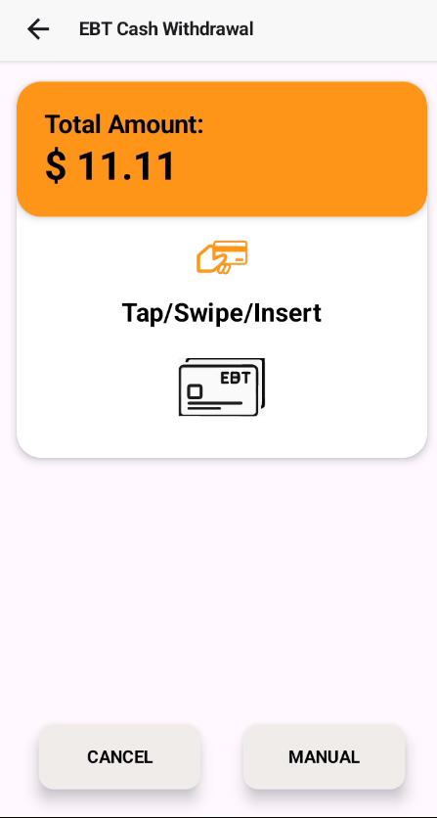
- If the service code starts with 2 or 6, it generally indicates that the card supports EMV chip functionality. The terminal should not process the swipe transaction immediately. Instead, it should prompt the customer with “Please Insert/Tap Card” and attempt chip processing first. If the chip transaction fails after the allowed retry attempts, then the terminal should proceed with swipe mode as a fallback transaction.
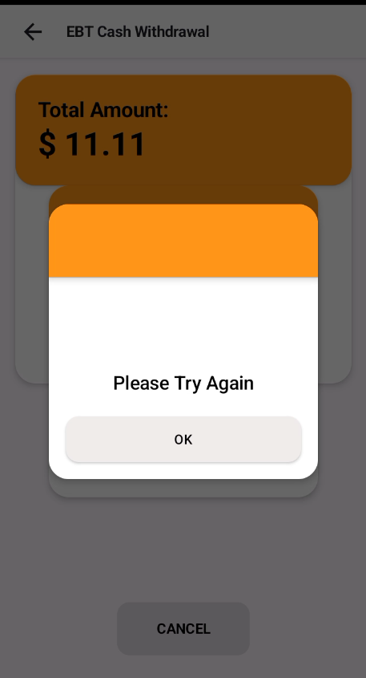
- If the Manual button is clicked, the application also switches to the Manual Entry scenario.

- In case card read successful through Tap,Chip,Swipe,Manual read then transaction continues to PIN prompt

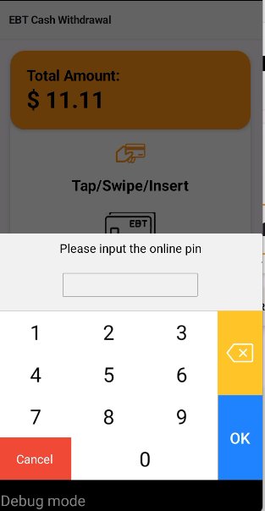

- Wait for the transaction to complete.
- If On transaction success, APPROVED screen will be displayed



- If the transaction fails DECLINED screen will be displayed.

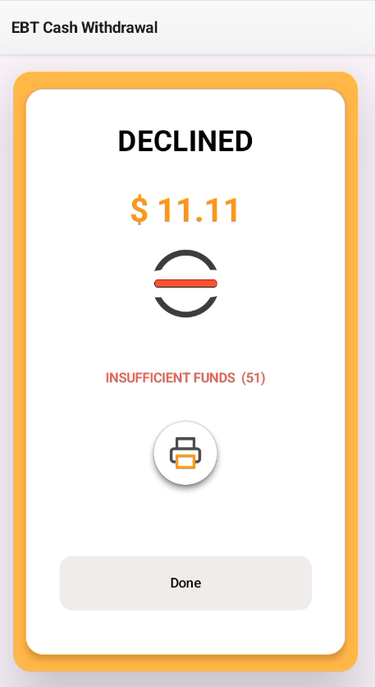
- Click on “Done” to return to Dashboard.

Terminal prints Merchant Copy then Customer Copy. Transaction complete

6.3 Receipt Formats
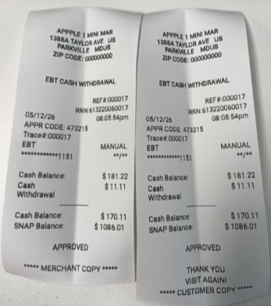

7. EBT Balance Inquiry

7.1 Overview
Transaction Type | EBT Balance Inquiry
Processing Codes | 319800 (SNAP) / 319600 (Cash)
Entry Modes | Insert / Tap / Swipe / Manual
PIN Required | Yes
Receipt Printed | Balance receipt (optional)
Funds Debited | No — inquiry only

7.2 Step-by-Step Screen Prompts
- Select the EBT Balance Inquiry menu option from dashboard.



- On selecting EBT Balance Inquiry the app will prompt to select SNAP or CASH option.

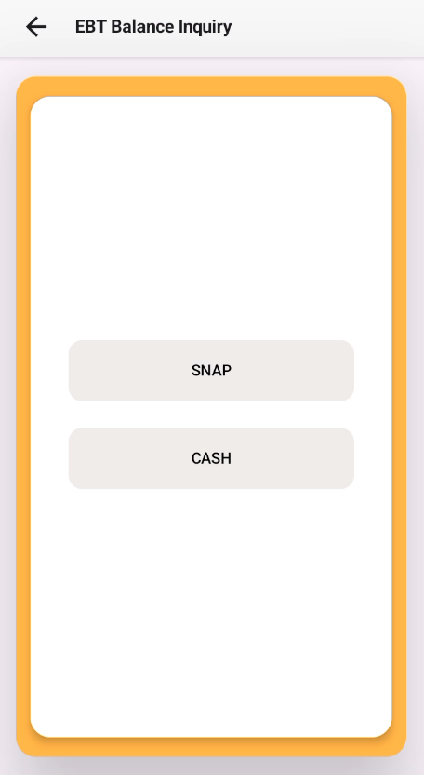

- Select the option for which Balance Inquiry needs to be done
- The application will navigate to Card presentation screen with Tap/Insert/Swipe/Manual option.
- Present the card with either of the options

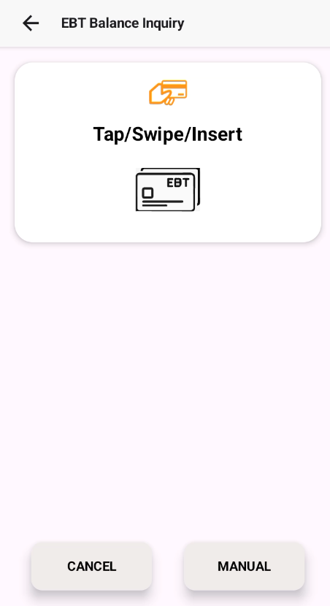

- If the service code starts with 2 or 6, it generally indicates that the card supports EMV chip functionality. The terminal should not process the swipe transaction immediately. Instead, it should prompt the customer with “Please Insert/Tap Card” and attempt chip processing first. If the chip transaction fails after the allowed retry attempts, then the terminal should proceed with swipe mode as a fallback transaction.
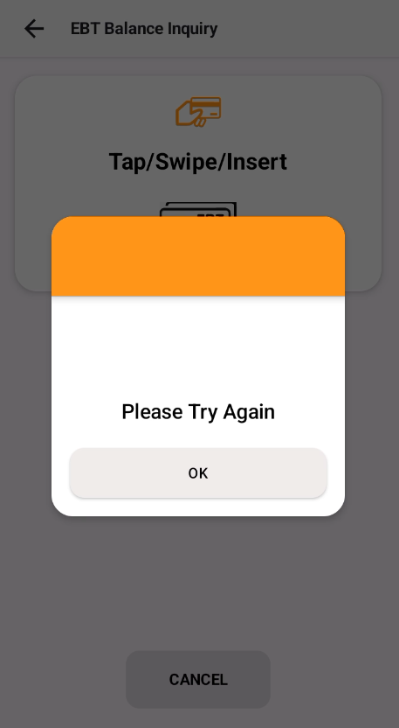
- If the Manual button is clicked, the application also switches to the Manual Entry scenario.



- In case card read successful through Tap,Chip,Swipe,Manual read then transaction continues to PIN prompt.

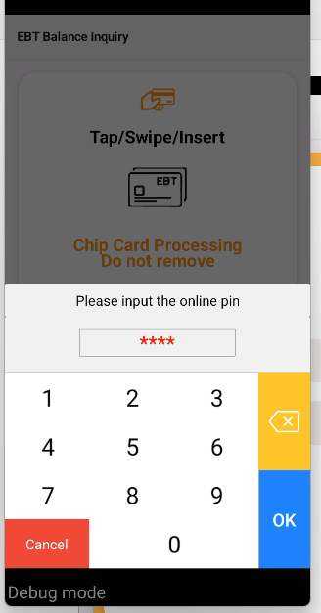
- Wait for the transaction to complete.
- On transaction success, APPROVED screen will be displayed
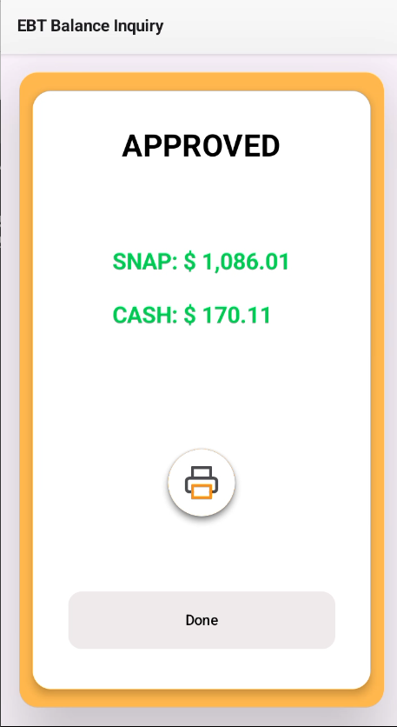
- If the transaction fails DECLINED screen will be displayed.



- Click on “Done” to return to Dashboard.
- Terminal prints Merchant Copy then Customer Copy. Transaction complete

7.3 Receipt Formats

Balance SNAP Inquiry Receipt

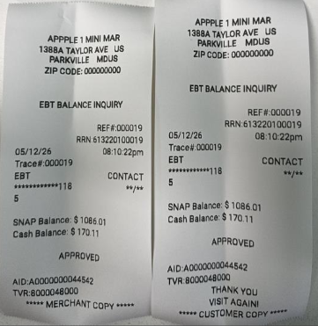

8. EBT Void Last Transaction

8.1 Overview
Transaction Type | EBT Void Last
Processing Code | 000040
Applicable To | EBT SNAP Purchase / EBT Cash Purchase
PIN Required | Yes
Receipt Printed | Void Merchant Copy + Void Customer Copy
Restriction | Can only void the MOST RECENT approved transaction in the current session

⚠ Voids can ONLY be performed on the last approved transaction. To reverse an older transaction.

8.2 Step-by-Step Screen Prompts
A purchase transaction was successfully completed. Subsequently, the customer requested to cancel the transaction, and we processed a 'Last Transaction Void' to reverse it.
- Select the EBT Void Last menu option from dash board.


- On the transaction list screen, you can search for a transaction using the RRN or Approval Code. Select the required transaction from the list, then perform the Void transaction.

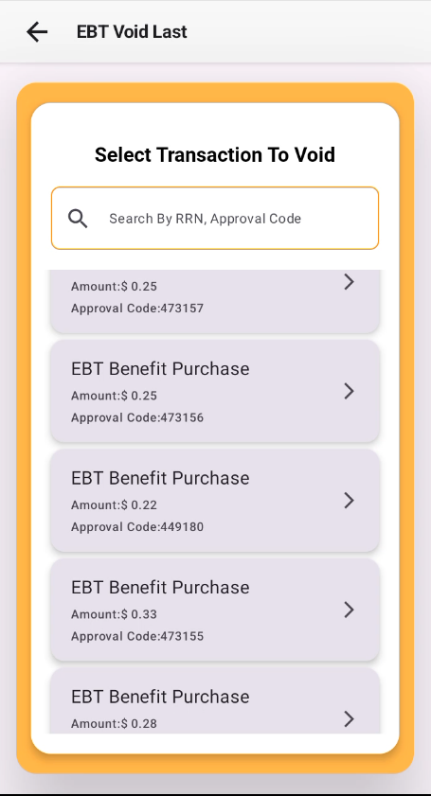

- Click on Confirm after that terminal show the approval or decline
- If transaction is decline this screen will displayed



- On transaction success, APPROVED screen will be displayed

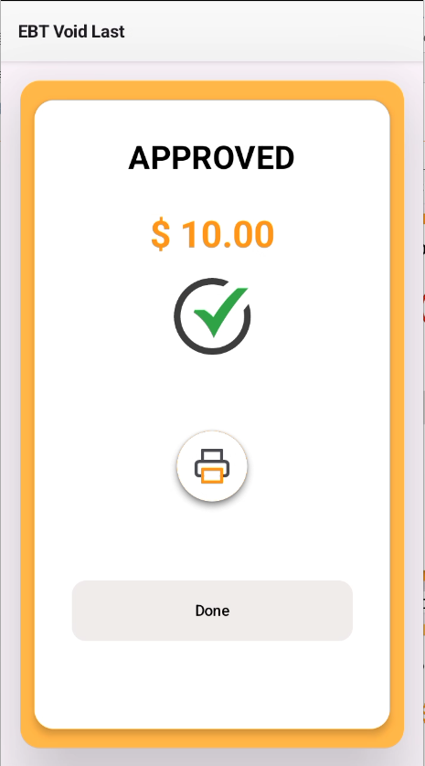
- Terminal prints Merchant Copy then Customer Copy. Transaction complete
⚠ If void is declined with 'No Account' or 'Invalid Reversal', the amount, Auth Code, or Terminal may not match the original.

8.3 Receipt Formats

EBT Void Last Receipt

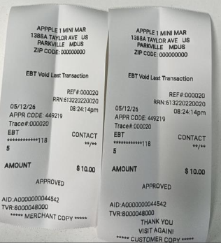

9. EBT Voucher Settlement

9.1 Overview
Transaction Type | EBT Voucher Settlement
Entry Mode | Manual (voucher number + approval code)
Sub-Types | Purchase or Return
PIN Required | No (voucher code is used instead)
When Used | When the terminal was offline at time of original transaction and a paper voucher was issued
NOTE: Voucher Settlement is used to settle paper vouchers issued during outages. Requires both the Voucher Number and Approval Code printed on the voucher.

9.2 Screen Prompts
- Select the EBT Voucher Settlement menu option from dashboard.

- On selecting EBT Voucher Settlement the app will prompt to select Food Stamp option.

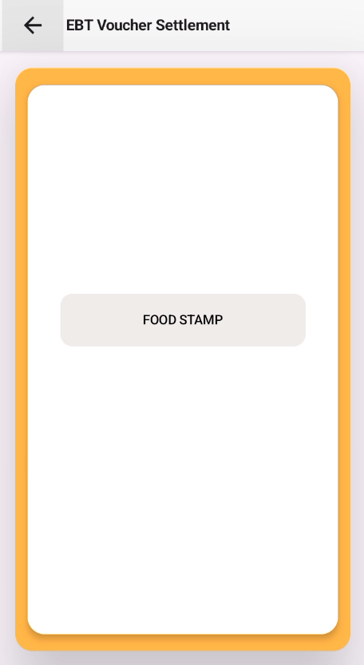

- On selecting Food Stamp the app will prompt to Enter Card Number

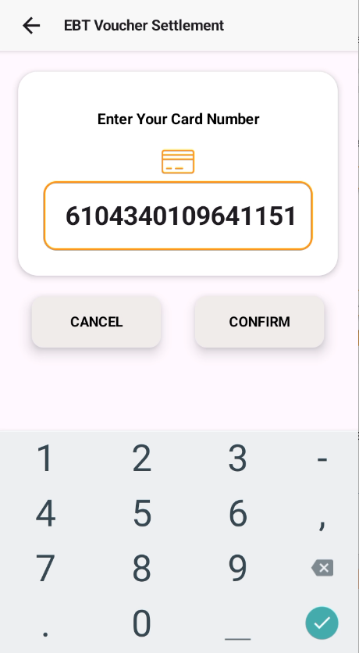
- Click on Confirm.
- App will prompt to Enter Voucher Code.
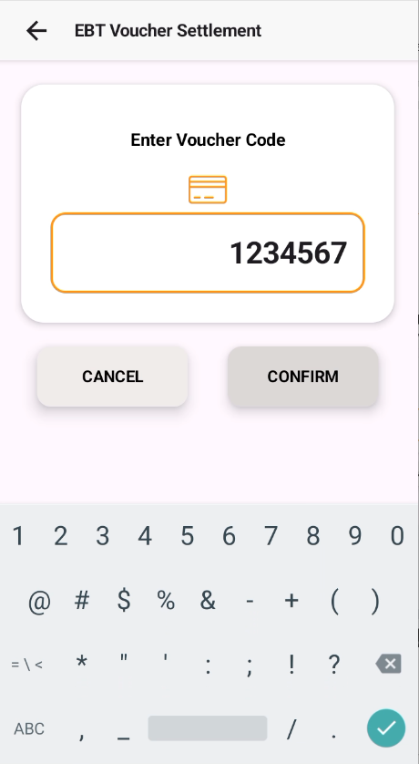

- Enter the Voucher Code & Confirm.
- App will prompt to Enter Authorization Code.
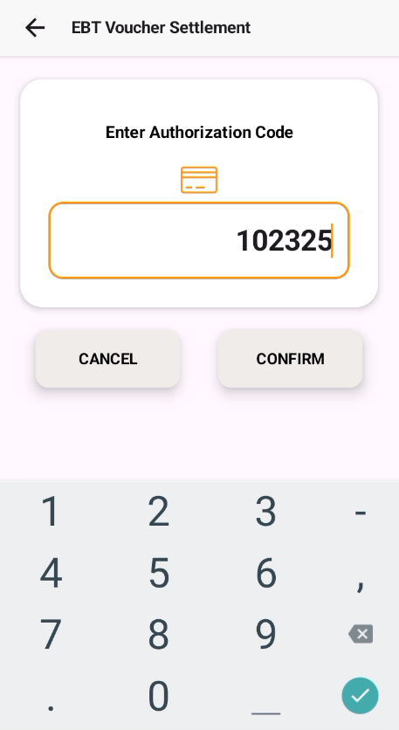
- Enter the Authorization Code & Confirm.
- The App will prompt to select Purchase or Return.
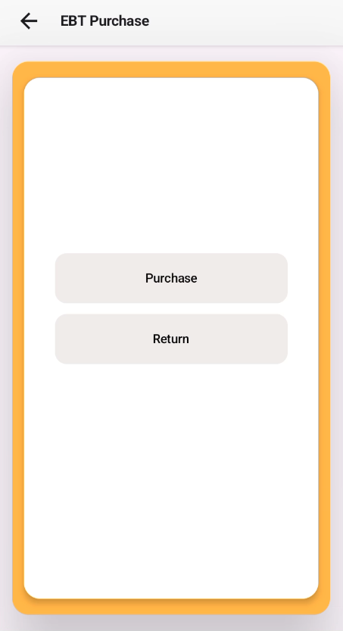

- On selecting Purchase the app will prompt to Enter Purchase Amount.

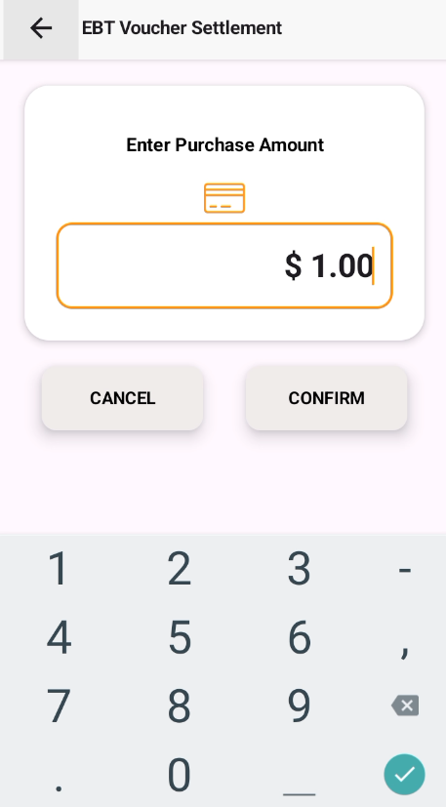
- Enter the amount & confirm.
- On Selecting Return the app will prompt to enter the Supervisor Credentials.
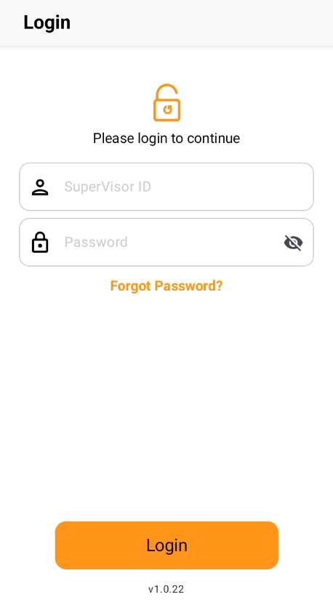

- On validating the credentials entered the app will prompt to Enter Return amount.

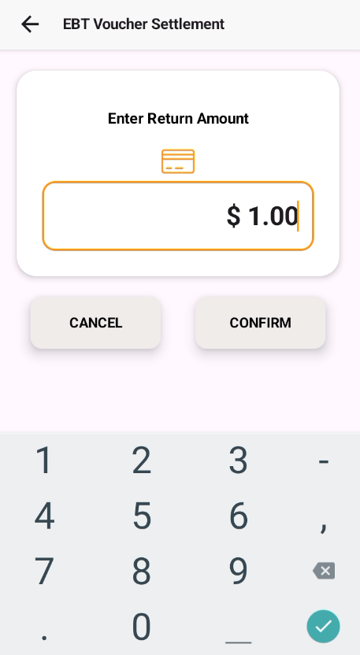
- Wait for the transaction to complete.
- On transaction success, APPROVED screen will be displayed


- If the transaction fails DECLINED screen will be displayed.


- Confirm and submit. Terminal processes and prints a receipt.

9.3 Receipt Format

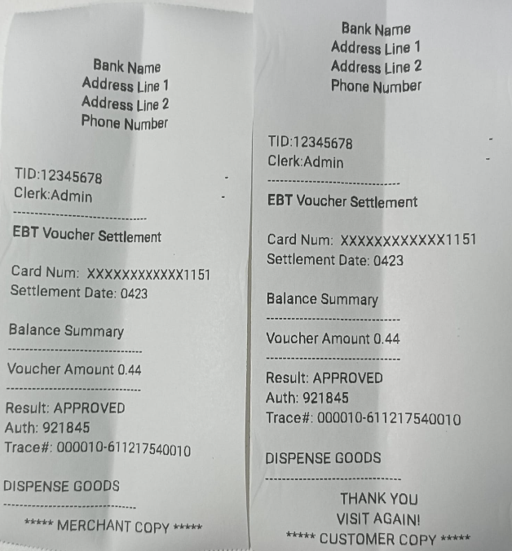

10. Manual Card Entry

10.1 When to Use Manual Entry
Manual entry is used when the physical card cannot be read by the terminal.
- Chip insert fails 3 consecutive times
- Magnetic stripe is damaged or unreadable
- Contactless is not available and chip fails
- Alternatively: wait 30 seconds on the Insert/Tap/Swipe screen — the terminal will offer
Manual Entry automatically

⚠ Manual entry has a higher fraud risk. Always verify the cardholder's identity with a government-issued photo ID before proceeding.
NOTE: Manual entry is available for SNAP Purchase, Cash Purchase, SNAP Return, Balance Inquiry, Cash Purchase with cashback, Cash Withdrawals and Voucher Settlement
10.2 How to Perform Manual Entry
- On selecting EBT Purchase SNAP benefits the app will navigate to screen having EBT SNAP benefit Purchase & EBT Cash benefit Purchase option.

You can select one options.
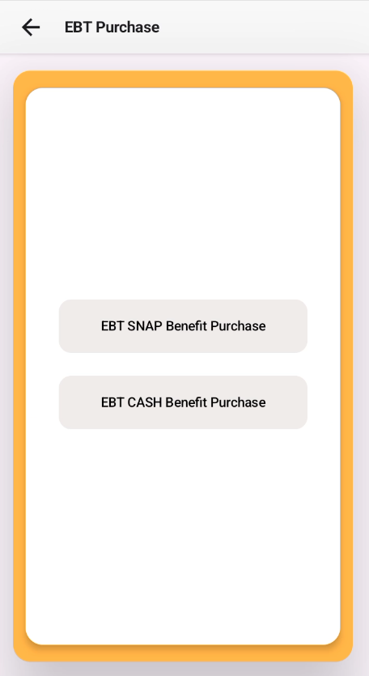
- Cashier types the sale amount (e.g. 100.00 for $1.00) and presses CONFIRM.

- Terminal confirms the amount and prompts for card.

- Click the Manual button, then the terminal prompts the user to enter the card number. Key in the 16-digit EBT card number and press OK to process the transaction
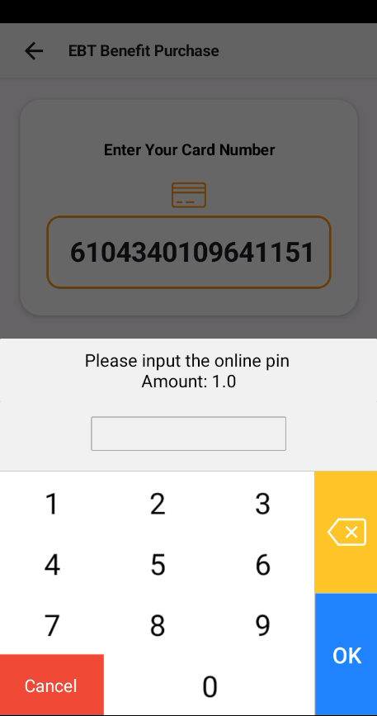
- Cardholder enters PIN at the PIN prompt. Terminal sends authorization with DE22 = 012.
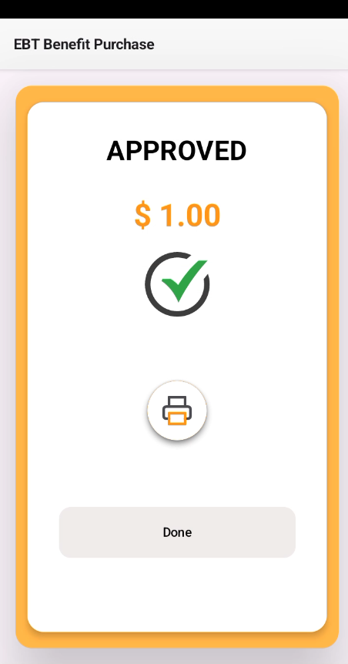
- Confirm and submit. Terminal processes and prints a receipt.

10.2 Receipt Format

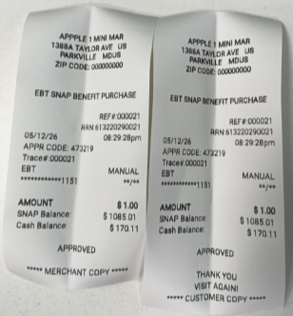

11. ISO 8583 Request / Response Overview
Every EBT transaction communicates with Conduent using the ISO 8583 financial messaging standard. This section is provided for reference and technical support purposes only.

11.1 Message Types (MTI)
0200 | Authorization Request — sent by terminal to request approval
0210 | Authorization Response — sent by Conduent (Approved / Declined)
0420 | Void / Reversal Request — sent by terminal to cancel a transaction
0430 | Void Response — Conduent confirms or rejects the void
0800 | Network Sign-On Request — sent at startup to connect to Conduent
0810 | Network Sign-On Response — confirms terminal is online

11.2 Key Data Fields
DE02 PAN | Card number (last 4 digits only on receipts)
DE03 Processing Code | 6-digit transaction type (e.g. 009800 = SNAP Purchase)
DE04 Amount | Amount in cents, 12 digits (e.g. 000000002500 = $25.00)
DE11 STAN | System Trace Audit Number — unique message ID
DE37 RRN | Retrieval Reference Number — matches request to response
DE38 Auth Code | 6-character authorization code on approval
DE39 Response Code | 00/40 = Approved; other = Declined (see Section 14)
DE41 Terminal ID | 8-character POS terminal identifier
DE42 Merchant ID | 15-character merchant account identifier
DE49 Currency | 840 = US Dollars
DE52 PIN Data | Encrypted PIN block — never readable in plain text
DE54 Balance | Remaining benefit balances returned after approval
DE55 EMV Data | Chip card cryptographic data (chip/contactless only)

11.3 Transaction Message Flow
Step | Action | Message
1 | Cashier enters amount; cardholder taps/inserts/swipes card & enters PIN | — (local)
2 | Terminal sends authorization request to Conduent | 0200 → Conduent
3 | Conduent verifies PIN and checks benefit balance | — (at Conduent)
4 | Conduent sends approval or decline response | 0210 ← Conduent
5 | Terminal prints receipts and shows balance | — (local)

11.4 Sample Messages
Sample SNAP Purchase Request (0200):
"1":"0000000000020002",
"2":"6104340109641144",
"3":"009800",
"4":"000000000300",
"7":"0414225228",
"11":"000003",
"12":"225228",
"13":"0414",
"15":"0414",
"17":"0414",
"18":"5499",
"22":"011",
"32":"00004000007",
"37":"610422520003",
"41":"12345678",
"42":"123456789012345",
"43":"1388A&nbsp;TAYLOR&nbsp;AVE&nbsp;&nbsp;&nbsp;US&nbsp;&nbsp;PARKVILLE&nbsp;&nbsp;&nbsp;&nbsp;MDUS",
"48":"APPPLE&nbsp;1&nbsp;MINI&nbsp;MAR",
"49":"840",
"52":"4cd1947429939c7d",
"58":"00000000016",
"111":"EB0070008596",
"127":"04142252280000000000"

Sample Approval Response (0210):
"1":"0000000000020002",
"2":"6104340109641144",
"3":"009800",
"4":"000000000300",
"7":"0414225228",
"11":"000003",
"12":"225228",
"13":"0414",
"15":"0415",
"17":"0414",
"18":"5499",
"22":"011",
"32":"00004000007",
"37":"610422520003",
"38":"921248",
"39":"00",
"41":"12345678",
"42":"123456789012345",
"43":"1388A&nbsp;TAYLOR&nbsp;AVE&nbsp;&nbsp;&nbsp;US&nbsp;&nbsp;PARKVILLE&nbsp;&nbsp;&nbsp;&nbsp;MDUS",
"48":"APPPLE&nbsp;1&nbsp;MINI&nbsp;MAR",
"49":"840",
"54":"9602840C0000000000019802840C000000051700",
"58":"00000000016",
"111":"EB0070008596",
"127":"2395921248&nbsp;Approved"

12. Processor ID (PID),Terminal ID (TID) & Merchant ID (MID) Setup
- The PID ,TID and MID identify which physical terminal and which merchant account processes each transaction. They are set during onboarding and must match Conduent's records exactly.

12.1 Viewing PID ,TID and MID
1. When entering the TID and MID, you can either enter them manually or use the default values. The PID provided by Conduent must be entered manually Alternatively, you can configure these details in the TMS portal and push them to the device.
- From Main Activation start
- Enter The PID, TID and MID
- Enter the Admin Password.

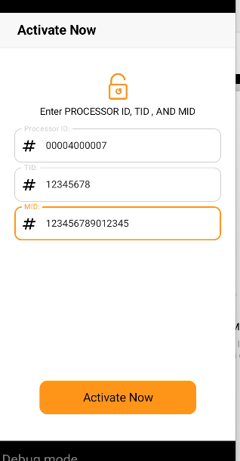

12.2 Changing the Terminal ID (TID)
⚠ Only change the TID if instructed by EazyPayTech Support. An incorrect TID will cause ALL transactions to be declined.
- Go to Settings and the logout option will be displayed.
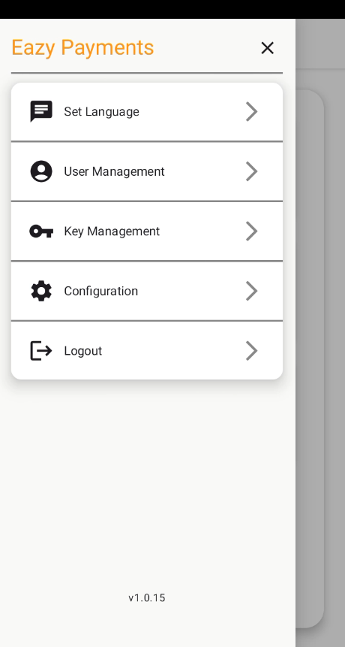
- There will show the options Cancel or Yes .
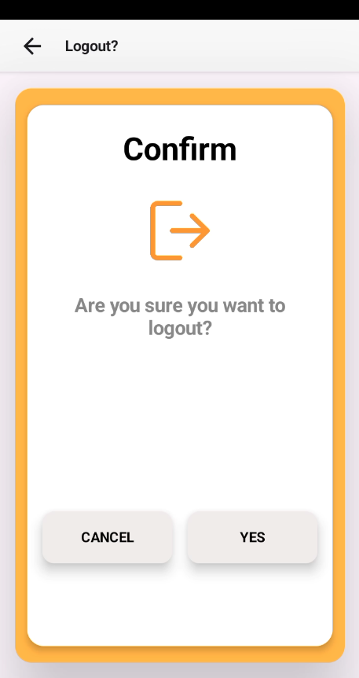
- If you select Yes, the TID option will appear → Select Change TID
Type the new 8-character TID exactly as provided by EazyPayTech.
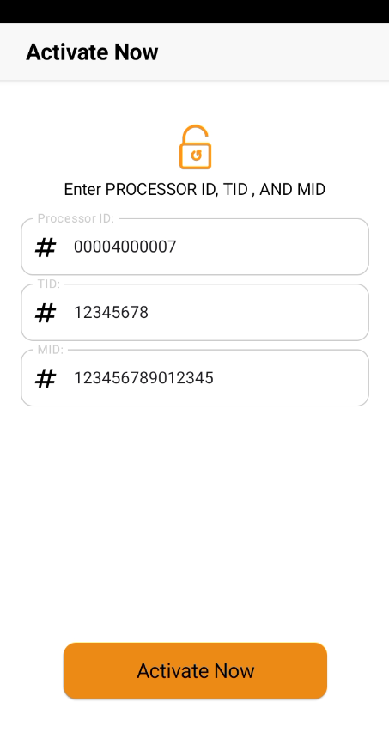
- Click on activation button then show the login ID and Password.
- Enter the Administrator login ID and Password.
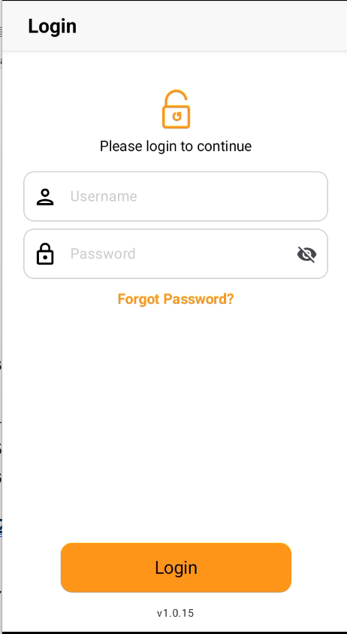
- Press Login Button to confirm.
- The terminal performs a network sign-on (0800) to validate the new TID.
- If sign-on succeeds, the new TID is saved. If it fails, the previous TID is restored automatically.

12.3 Changing the Merchant ID (MID)
⚠ Only change the MID if instructed by EazyPayTech or Conduent. An incorrect MID causes transactions to settle to the wrong account.
- Go to Settings and the logout option will be displayed.

- There will show the options Cancel or Yes.

- If you select Yes, the MID option will appear → Select Change MID and Type the new 15-character MID exactly as provided.

- Click on activation button then show the login ID and Password.
- Enter the Administrator login ID and Password.

- Press Login button then a network sign-on test runs automatically.

13. Merchant Configuration & Parameters
Access via: Main Menu → . Settings → Merchant Configuration → Enter Admin PIN

13.1 Configuration Parameters
Parameter | Default | Description
Store Name | Your business name | Appears on all receipts. Max 24 characters.
Store Address Line 1 | Street address | Printed on receipt header. Max 28 characters.
Store Address Line 2 | City, State, ZIP | Printed below address line 1.
FNS Number | EB0070008596
Merchant Type(MCC) | 5499 | Every Industry different MCC
State Code | 39
County Code | 000
Postal Service code | 0000000000
Receipt Details | Show Options | Terminal display the receipt Header and Footer format
Language | English | Terminal display and receipt language.
Reader Settings | Show Options | Reader On or OFF settings

Changing Parameters
- Navigate to Main Menu → 1. Settings → Merchant Configuration.


- Enter the Administrator Password.
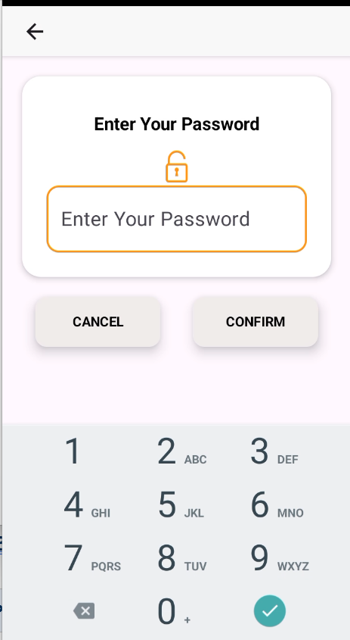
- Select the parameter to change.
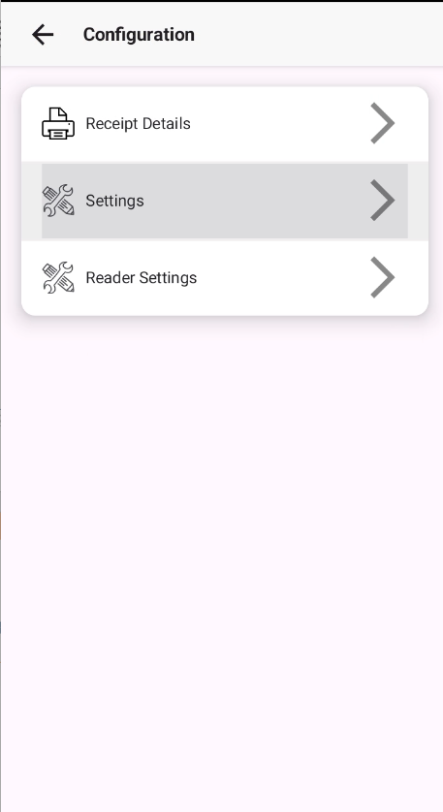
- Select Settings; multiple options will be displayed.

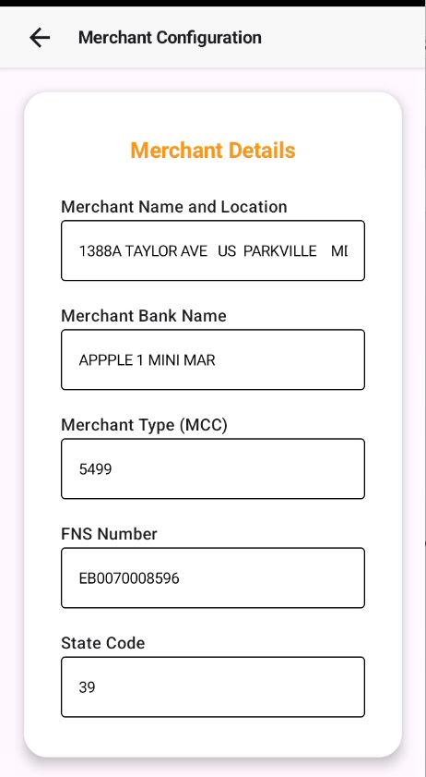
- Enter the new value and press SAVE button.
- Select 'Save Changes' and confirm.
NOTE: Some changes (e.g. network host settings) require a terminal restart.

13.3 Network / Host Settings
⚠ Never change the network host address or port unless directed by EazyPayTech Support.
Primary Host | ebt.conduent.com
Backup Host | ebt-backup.conduent.com
Port | 8583
Protocol | TLS 1.2 / 1.3 encrypted
Timeout | 30 seconds
Retry Count | 3 attempts before offline fallback

14. Error Codes & Troubleshooting

14.1 Response Codes (DE39)
Code | Description | Resolution
00 / 40 | Approved | Transaction successful. No action needed.
13 | Invalid Amount | Re-enter the correct amount. Amount cannot be zero.
14 | Invalid Card Number | Verify card number. Try manual entry.
30 | Format Error | Required field missing. Contact EazyPayTech Support.
41 | Lost Card | Do not return card. Contact EazyPayTech Support.
42 | No Account on File | Card not found. Verify card number or call benefit agency.
51 | Insufficient Funds | Ask cardholder to try a smaller amount or check balance.
54 | Expired Card | Card has expired. Cardholder must contact their agency.
55 | Invalid PIN | Wrong PIN entered. Card locks after 3 failed attempts.
57 | Transaction Not Permitted | This transaction type not allowed for this card.
61 | Return Exceeds Auth | Return amount is greater than original purchase.
75 | PIN Tries Exceeded | Card is locked. Cardholder must call their benefit agency.
76 | Invalid Reversal | Void details do not match original. Contact Support.
86 | Invalid ARQC | Chip cryptogram rejected. Retry; if repeated, try manual entry. Contact Support.
90 | Processor Not Logged On | Terminal offline. Perform network sign-on from Settings.
91 | Authorizer Not Available | Conduent timeout. Check internet connection and retry.
96 | System Malfunction | Conduent system error. Wait 60 seconds and retry.
S5 | PIN Not Selected | Cardholder must call their agency to set up a PIN.
TL | Invalid HIP Amount | Contact EazyPayTech Support.

14.2 Hardware Error Messages
CARD READ ERROR — PLEASE RETRY | Remove card, clean chip, reinsert slowly. Try 3 times then use manual entry.
PRINTER OUT OF PAPER | Open printer cover, insert new thermal paper roll, close and press retry.
PRINTER ERROR | Restart the application. If repeated, contact EazyPayTech Support.
NETWORK TIMEOUT | Check Wi-Fi or mobile data. Retry sign-on from Settings → Network.
TRANSACTION REVERSED | Terminal auto-voided due to no response. Verify original before re-processing.
LOW BATTERY | Connect to power immediately. Do not process below 10% battery.
TAMPER DETECTED | STOP using terminal immediately. Call EazyPayTech Support — Security option.

14.3 Quick Fixes

All transactions declined | Terminal may be offline. Settings → Network → Sign On. Check internet.
Receipt paper jammed | Power off, open printer cover, remove jammed paper, reload, power on.
Screen frozen | Hold power button 10 seconds. Restart, relaunch app.
Cannot void transaction | Batch may be settled. Voids only work same session. Contact Support.
Balance shows $0 but funds exist | Ask cardholder to call their benefit agency helpline.
'Invalid ARQC' on every card | Encryption keys may be outdated. Contact EazyPayTech for key reload.

15. POS Logs Collection and Upload Process TMS Portal
Purpose
To capture logs for troubleshooting errors or monitoring processes on the POS device, you must start log recording before performing the activity.

- Power on the POS device.
- Open the Hardware Manager application.
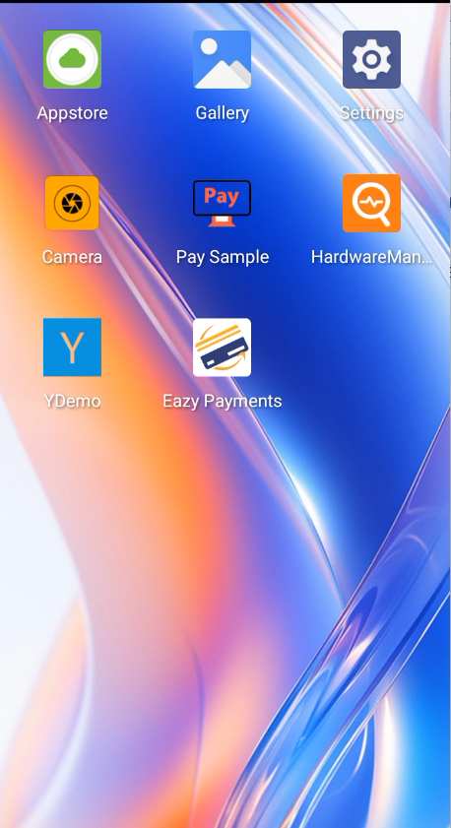

- Tap on the More option.
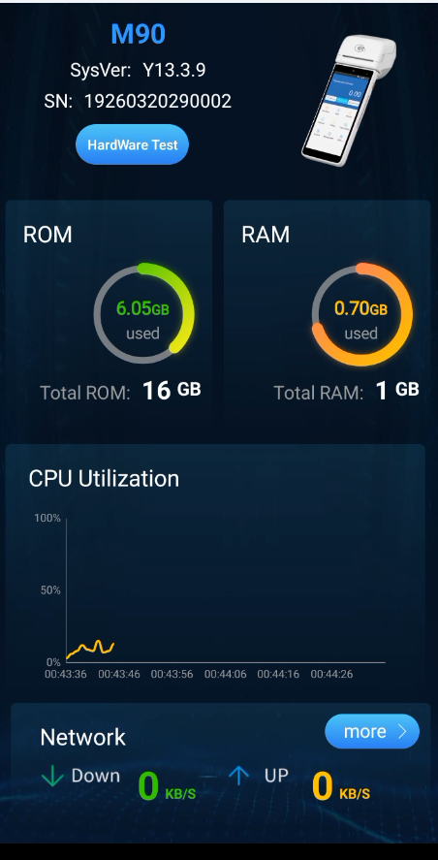
- Scroll down and select System Version.
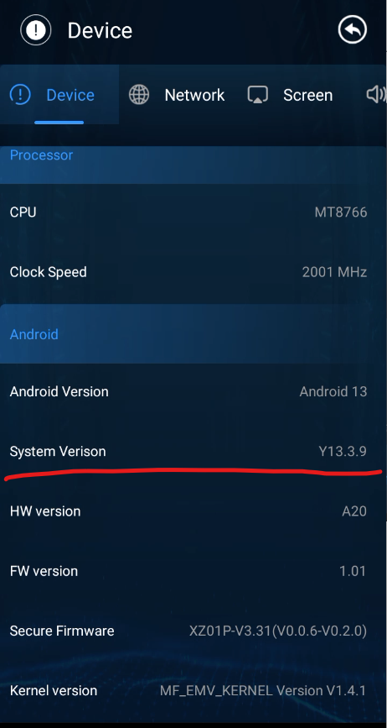
- Tap the System Version option five (5) times.
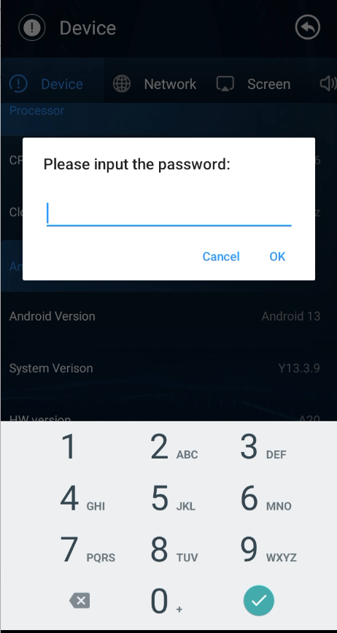
- A dialog box will appear.
- Enter the password 88132279..
- Tap OK to confirm.
- Log recording will now start.
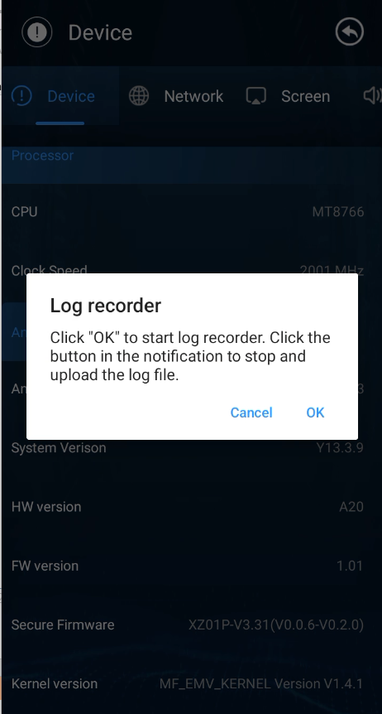

📌 A notification will appear in the status bar indicating that log recording is active.
⚠️ Do not stop the recording at this stage.

- Perform the Activity
Perform the required operation on the device.
Example: Execute an EBT SNAP Benefit Purchase transaction.
Ensure the issue or process is reproduced while log recording is active.

- Stop Recording and Upload Logs to TMS Portal Steps:
- Swipe down the status bar.
- Locate the notification indicating Log Recorder is running.
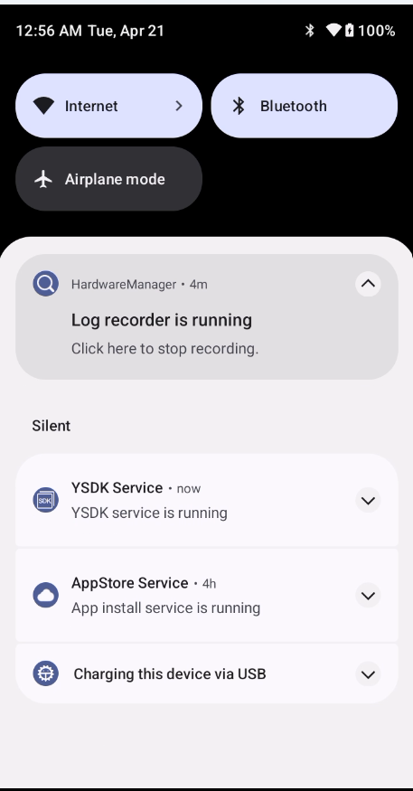

- Tap on the notification.
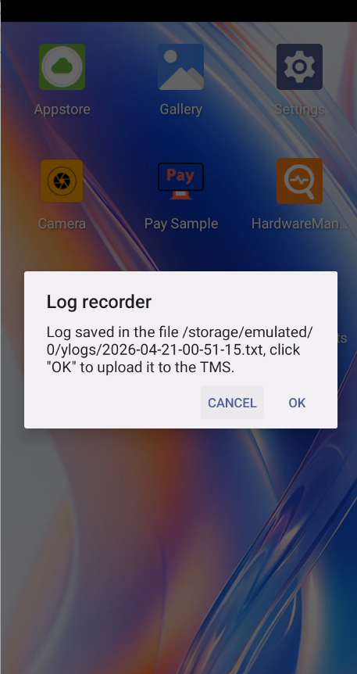
- A prompt will appear with options: Cancel or OK.
- Select OK.
- The log file will be saved and automatically uploaded to the TMS portal
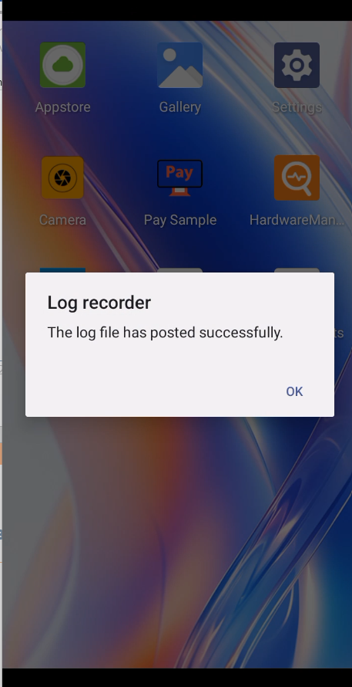

16. MoreFun M90 Setup Guide
16.1 Insert Paper Roll
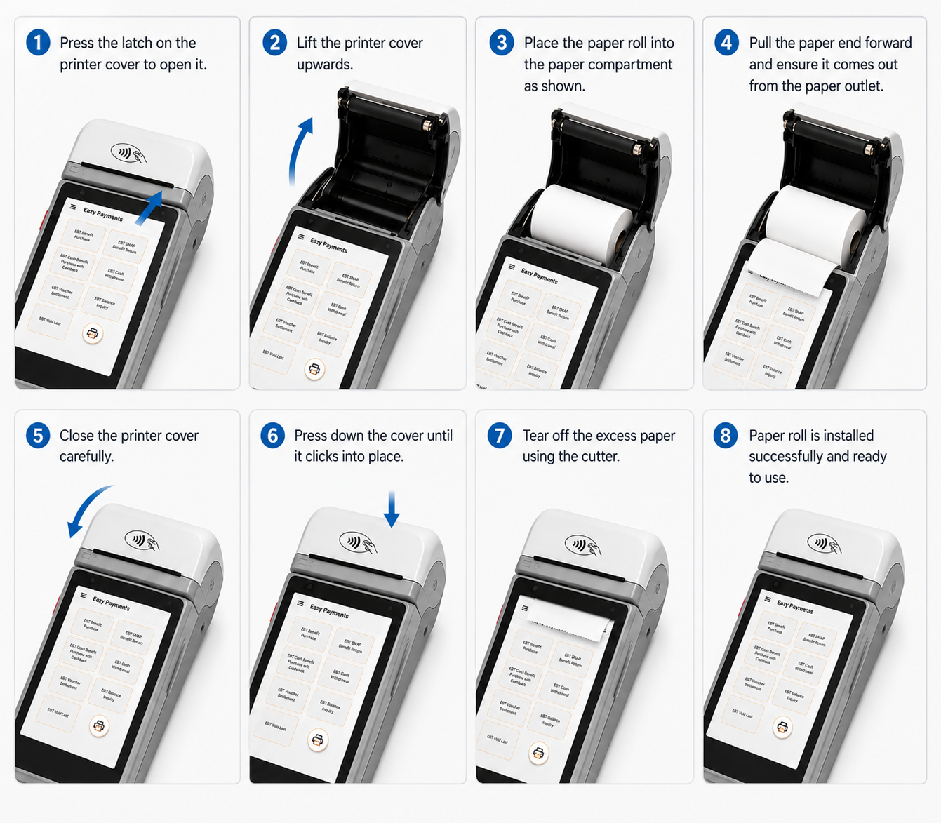

16.2 MoreFun M90 Features
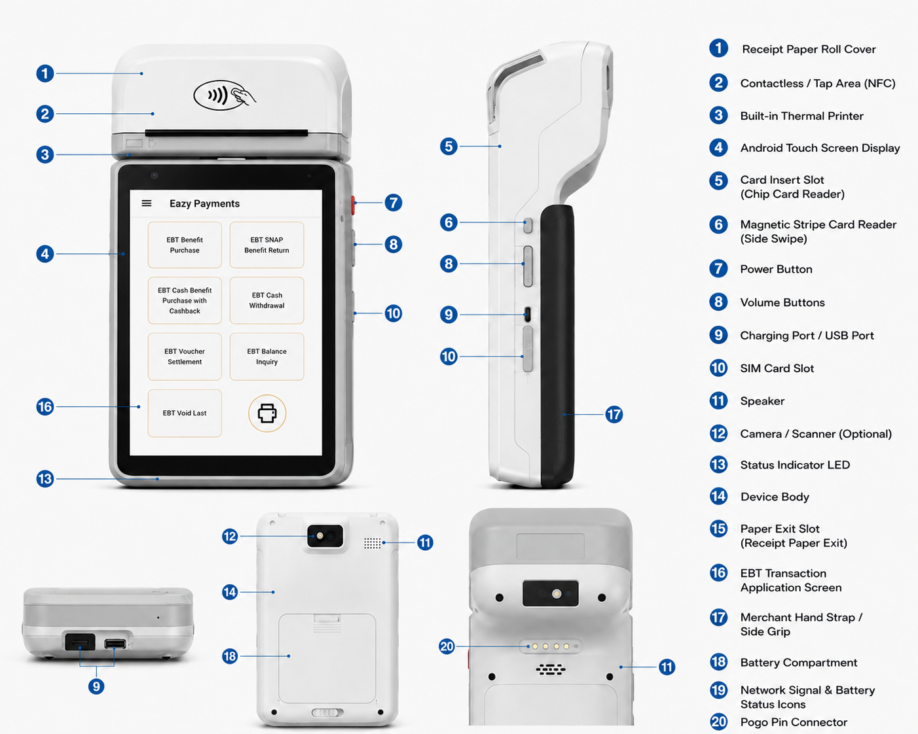

16.3 Maintenance and Troubleshooting – MoreFun M90
Daily Preparation
- Check the terminal battery level before store opening.
- Verify network connectivity Wi-Fi.
- Ensure the printer paper roll is available.
- Confirm the terminal displays the home screen properly.
Installing a Paper Roll
- Open the printer cover.
- Remove any remaining paper roll.
- Insert a new thermal paper roll correctly.
- Pull a small amount of paper outside the printer.
- Close the printer cover until it clicks.

Cleaning the Terminal
- Use a soft cloth slightly dampened with water or alcohol-based cleaner to clean the terminal surface.
Caution:
Do not use thinner, chemical solvents, or spray cleaners directly on the screen or keypad.
Printer Does Not Print
- Check the battery charge level.
- Ensure the paper roll is installed correctly.
- Verify the printer cover is closed properly.
- Replace the paper roll if empty.

Printer Paper Jam
- Open the printer cover.
- Remove jammed or damaged paper carefully.
- Reload the paper roll correctly.
- Close the printer cover securely.

Terminal Does Not Power On
- Charge the terminal using the original power adapter.
- Check the charging cable connection.
- Press and hold the power button for a few seconds.

Network Connection Issues
- Verify Wi-Fi or SIM network availability.
- Restart the terminal and reconnect the network.
- Contact support if the issue continues.

Card Reader Issues
- Ensure the card is inserted or tapped properly.
- Clean the card reader area if required.
- Retry the transaction with another card if needed.

17. Glossary
This glossary provides definitions for commonly used acronyms, terms and words used in EBT and in this manual.

Field | Value
Authorization | The approval of retailer transactions by the EBT contractor online from their host computer.
Balance Inquiry | A non-financial transaction that allows an EBT cardholder to obtain the current balance of their SNAP or Cash benefits.
Business Day | All weekdays excluding those on which the Federal Reserve Bank is closed.
Cardholder / Participant | An individual entitled to EBT benefits by the state agency.
Conduent | The EBT processing contractor selected by the state agency to perform EBT network services.
DE39 | Data Element 39 — the ISO 8583 field containing the transaction response code.
EBT | Electronic Benefits Transfer — an electronic payment system that transfers benefit values from the program to cardholders and retailers.
EMV | Europay, Mastercard, Visa — the international standard for chip card transactions.
FNS Number | Federal Nutrition Service authorization number assigned to each retailer.
ISO 8583 | International standard defining the format of messages for financial transactions.
MCC | Merchant Category Code — identifies the type of business for transaction processing.
MID | Merchant ID — 15-character account identifier assigned to each merchant location.
MTI | Message Type Indicator — identifies the ISO 8583 message type (e.g., 0200 = Authorization Request).
PAN | Primary Account Number — the EBT card number.
PID | Processor ID — unique identifier assigned by Conduent to the EBT processor.
PIN | Personal Identification Number — 4-digit confidential number used with the EBT card as electronic signature.
POS | Point-of-Sale — the electronic device used to process EBT transactions at retail locations.
RRN | Retrieval Reference Number — matches each authorization request to its response.
SNAP | Supplemental Nutrition Assistance Program — federal food benefit program administered by USDA.
STAN | System Trace Audit Number — unique identifier for each transaction message.
TID | Terminal ID — 8-character identifier assigned to each POS terminal.
TLS | Transport Layer Security — encryption protocol used for all host communications.
TMS | Terminal Management System — portal for device configuration, updates, and log management.
DE | Data Element

*** End of Document ***

